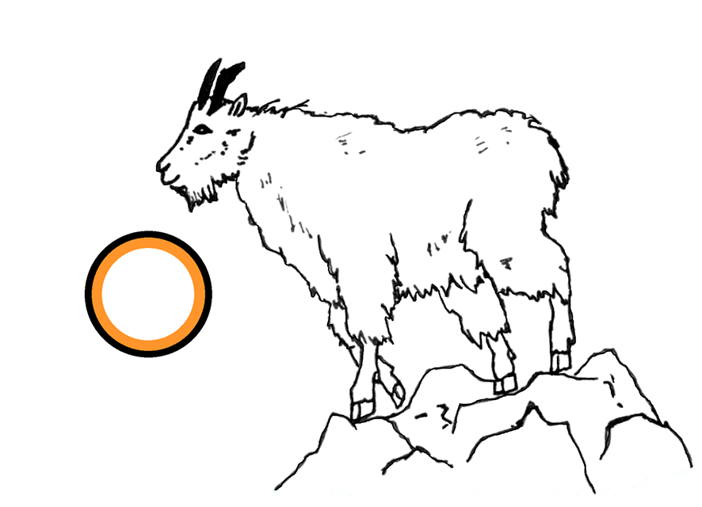
Art Contest Submission Form

This year, Climate Smart Glacier Country is hosting its first-ever ART CONTEST! The theme is Climate Smart ART and we are accepting any art you create to capture the spirit of sustainability and climate preparedness in your community. Whether that reminds you of zero-waste housing, forest adventuring, or mountain biking, send us art that depicts what Climate Smart means to you. The winners will be selected by a panel of artists, scientists, and community members, and awards and prizes will be presented at the Whitefish Winter Carnival in February. Submittals must be received by January 27th. Please drop off this form with your artwork at City Hall - attention Sophia Valenzuela. There will be four judging categories:

(1) Photography & Graphic Design
(2) Video (please keep videos 3-20 minutes long)
(3) Mixed Media (includes painting, sculpture, drawing, quilting, printmaking, and other media)
(4) Snow Sculpture

Applicant Name:
Applicant Email and Phone Number:
Category:
Description of Submission:
______________________________________________________________________________________________________________________________________________________________________________________________________________________________________________________________________________________________________________________________________________________________________________________________________________________________________________________________________________________________________________________________________________________________________________________________________________________________________________________

