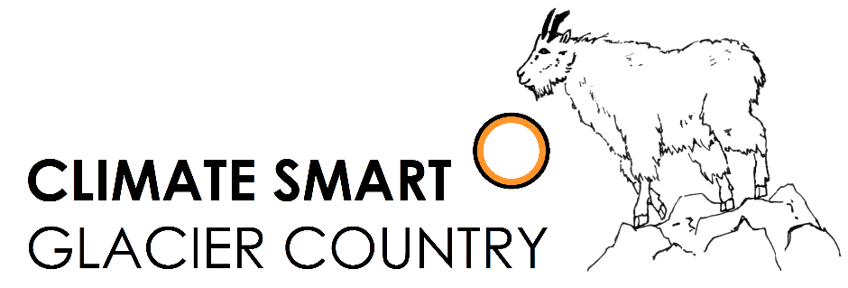

Climate Smart Champion: Youth Award

Application/Nomination Form
Climate Smart Glacier Country is a public-private partnership that seeks to understand and educate others about the implications of a changing climate in and around Glacier National Park. The partners include Glacier National Park, City of Whitefish, Flathead Electric Coop and numerous businesses, organizations and individuals. We focus on local solutions to the challenges of a changing climate while conserving energy and reducing dependence upon fossil fuels.
Students across the Flathead are doing great things to promote sustainability. The Climate Smart Champion: Youth Award will publicly recognize and celebrate individuals or groups (ages 8 to 18 years) that demonstrate leadership and initiative in sustainability practices. The application submission deadline is March 24, 2017.

General Information

Student/Group Information:
Name: Click or tap here to enter text.
Student names (for groups): Click or tap here to enter text.
Grade: Click or tap here to enter text.
School: Click or tap here to enter text.
Phone: Click or tap here to enter text.
Email: Click or tap here to enter text.
Nominator Information:
Name: Click or tap here to enter text.
Relationship to student/group: Click or tap here to enter text.
Phone: Click or tap here to enter text.
Email: Click or tap here to enter text.
Brief bio about student/group:
Click or tap here to enter text.

What initiatives and actions has the student or group undertaken to protect the environment and contribute to campus, local, and/or global sustainability? What was the result of these actions? There is no word limit! Be as specific and detailed as possible.
Click or tap here to enter text.

Want to include supplemental materials such as newspaper articles, proof of success (e.g. lbs of waste diverted), or pictures? Feel free to attach them to the application! We want to know how the student/group has protected the environment, affected the community, and realized the benefits of sustainability, so show us in the way that you think is best. For more information go to www.ClimateSmartGlacierCountry.org.

Submit your application to awards@climatesmartglaciercountry.org with the subject line “Youth Award Application.”
If you have any questions about the application process, please contact matt@climatesmartglaciercountry.org

