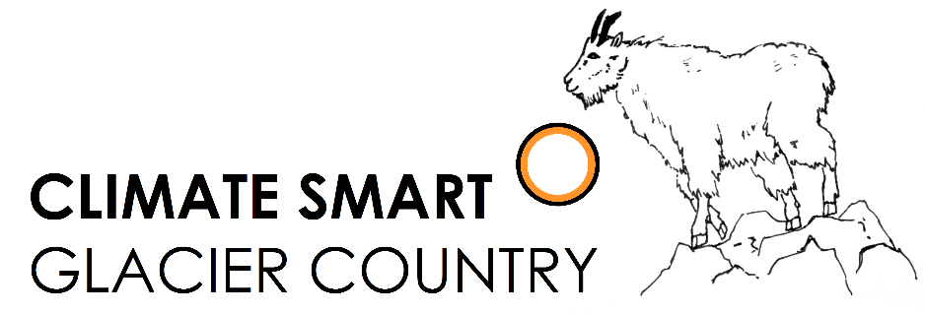

Climate Smart Champion: Community Leader Award

Nomination Form
Climate Smart Glacier Country is a public-private partnership that seeks to understand and educate others about the implications of a changing climate in and around Glacier National Park. The partners include Glacier National Park, City of Whitefish, Flathead Electric Coop and numerous businesses, organizations and individuals. We focus on local solutions to the challenges of a changing climate while conserving energy and reducing dependence upon fossil fuels.
Individuals across the Flathead are doing great things to promote sustainability. The Climate Smart Champion: Community Leader Award will publicly recognize and celebrate an individual that demonstrates leadership in climate smart practices. The application submission deadline is March 24, 2017.
General Information about Nominee
Name: Click or tap here to enter text.
Address: Click or tap here to enter text.
Phone: Click or tap here to enter text.
Email: Click or tap here to enter text.
(If nominating an individual) Nominator name and relationship to the nominee:
Click or tap here to enter text.
Nominator phone: Click or tap here to enter text.
Nominator email: Click or tap here to enter text.

Brief bio of the nominee:
Click or tap here to enter text.

Note: The following questions have no word limit! Be as specific and detailed as possible.

Initiatives and Actions

What initiatives and actions has the nominee undertaken to protect the environment and enhance sustainability in the Flathead Valley? What are the impacts of these activities on the community and the environment? Some examples of climate smart activities include:
- Public education
- Alternative transportation (e.g. organizing a bike share)
- Volunteering with environmental stewardship organizations
- Political action (e.g. advocating for environmentally friendly policies)
- Workplace initiative (e.g. implementing a recycling program at the workplace)
- Improved access to sustainability (e.g. starting a community garden, weatherizing low-income homes)
- Shining example (e.g. personal decisions and actions that serve as a model for others in our community)
The types and impacts of sustainability are diverse and far-reaching. Share the unique way the nominee has impacted the Flathead community with his/her climate smart leadership practices.
Click or tap here to enter text.

Want to include supplemental materials such as newspaper articles, proof of success (e.g. lbs of waste diverted), or pictures? Feel free to attach them to the application! We want to know how the nominee has made a difference in our community, so show us in the way that you think is best. For more information go to www.ClimateSmartGlacierCountry.org.

Submit your application to awards@climatesmartglaciercountry.org with the subject line “Community Leader Award Application.”
If you have any questions about the application process, please contact matt@climatesmartglaciercountry.org.

