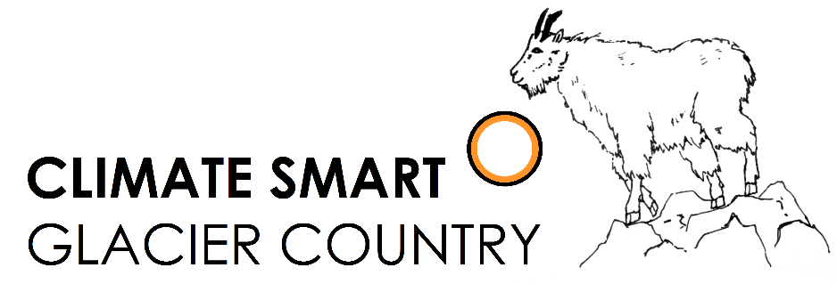

Climate Smart Champion: Business Award

Nomination/Application Form
Climate Smart Glacier Country is a public-private partnership that seeks to understand and educate others about the implications of a changing climate in and around Glacier National Park. The partners include Glacier National Park, City of Whitefish, Flathead Electric Coop and numerous businesses, organizations and individuals. We focus on local solutions to the challenges of a changing climate while conserving energy and reducing dependence upon fossil fuels.
Businesses large and small across the Flathead are doing great things to promote sustainability. The Climate Smart Champion: Business Award will publicly recognize and celebrate businesses that demonstrate leadership in climate smart practices. You may nominate your own business or a business that you think is deserving. The application submission deadline is March 24, 2017.

General Questions
Business Name: Click or tap here to enter text.
Business Address: Click or tap here to enter text.
# Employees: Click or tap here to enter text.
Years in business: Click or tap here to enter text.
Company Website: Click or tap here to enter text.
Business Contact Info:
Name: Click or tap here to enter text.
Email: Click or tap here to enter text.
Phone #: Click or tap here to enter text.
Type of Business (Products and Services): Click or tap here to enter text.
Note: The following questions have no word limit! Be as specific and detailed as possible

Initiatives and Practices (Required)
How is this business a leader in environmental sustainability? What environmental practices distinguish this business? Climate smart practices might include:
- Provide environmentally friendly products or services
- Community leadership in sustainability
- Recycling/waste reduction (e.g. composting food waste, recycling packaging)
- Water conservation (e.g. low-flow toilets, drought-tolerant plants)
- Energy conservation (e.g. energy efficient technology, behavioral changes)
- Green purchasing (e.g. purchase from local vendors, use recycled paper products)
- Alternative transportation (e.g. hybrid vehicles in fleet, bike share for employees)
- Use or production of renewable energy (e.g. solar power, heat pumps)
There are countless ways to be a sustainable leader in business. Tell us about your business!
Click or tap here to enter text.
Outcomes (optional)
What results or outcomes have your business realized because of your climate smart initiatives?
- Cost savings
- Increased public awareness
- Decreased carbon footprint
- Healthier working environment
- Community improvement
- Green innovation (technology, products, services)
- Other: the rewards from sustainability are diverse and pervasive. How have you benefited?

Click or tap here to enter text.
Future (optional)
What initiatives do you intend to implement in the following year?

Click or tap here to enter text.

Have additional materials you would like to include in your application, such as pictures, Energy Star Portfolio Manager Reports, or news articles? Feel free to attach them! We want to know how you have reduced your environmental footprint and the benefits of your actions, so show us in the way that you think is best. For more information go to www.ClimateSmartGlacierCountry.org.

Submit your application to awards@climatesmartglaciercountry.org with the subject line “Business Award Application.”
If you have any questions about the application process, please contact matt@climatesmartglaciercountry.org

